**School Of Information Technology**

**IT2553**

|  |  |
| --- | --- |
| **Admin No & Team Members Name:** | 201520M: Eden Will Sng Jin Xuan |
| **PEM Group:** | SF2102 |
| **Module:** | DSA |
| **Assignment:** | Tutorial 12 and 13 |

Solution:

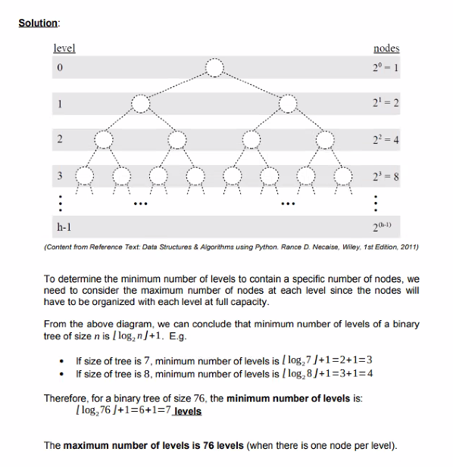

To determine the minimum number of levels to contain a specific number of nodes, we

need to consider the maximum number of nodes at each level since the nodes will

must be organized with each level at full capacity.

From the above diagram, we can conclude that minimum number of levels of a binary

tree of size n is / log, n/ +1. E.g.

* If size of tree is 7, minimum number of levels is / log,7/+1=2+1=3
* If size of tree is 8, minimum number of levels is /log, 8/+1=3+1=4

Therefore, for a binary tree of size 76, the minimum number of levels is:

[log,76|+1= 6 +1 =7 levels

The maximum number of levels is 76 levels (when there is one node per level)

2)

Solution:

From the above diagram, we can conclude that maximum number of nodes possible in

a binary tree occurs when it is a perfect binary tree (a full binary tree in which all the leaf nodes are at the same level)

For a binary tree with n levels, the maximum number of nodes is 2"-1. E.g.

* If number of levels is 3, the maximum number of nodes is 2°-1=7
* If number of levels is 4, the maximum number of nodes is 2'-1=15

Therefore, the maximum number of nodes in a binary tree with 5 levels is:

* 2-1=32-1=31 nodes (remember that there can only exist one node for the root)

3)

Solution:

Binary Tree A)

* Full Binary Tree
* Size: 7
* Height: 3
* Width: 2

Binary Tree B)

* Perfect Binary Tree
* Size: 15
* Height: 3
* Width: 8

Binary Tree C)

* Binary Tree
* Size: 14
* Height: 7
* Width: 2

Binary Tree D)

* Binary Tree
* Size: 7
* Height: 3
* Width: 3

Binary Tree E)

* Binary Tree
* Size: 11
* Height: 3
* Width: 5

4)

Solution:

A)

i)

Pre-order traversal

14 78 39 52 83 17 9 41 2 60 23 4 19

(ii)

In-order traversal

39 78 17 83 9 52 41 14 60 2 4 23 19

(iii)

Post-order traversal

39 17 9 83 41 52 78 60 4 19 23 2 14

(iv)

Breadth-first traversal

14 78 2 39 52 60 23 83 41 19 17 9

b) Identify all the leaf nodes

39 17 9 41 60 4 19

c) identify all the interior nodes

14 78 52 83 2 23

